ELECTRONIC SUPPLEMENTARY INFORMATION

A systematic literature review on the effects of synthesis conditions to the physicochemical properties of activated carbons and their performance in methylene blue adsorption

K. Z. Abu Bakar¹, R. R. Nasaruddin^{1,}*, N. S. Engliman¹, N. Ismail²

¹Department of Biotechnology Engineering, Kuliyyah of Engineering, International Islamic University Malaysia, 53100 Jalan Gombak, Kuala Lumpur

²Faculty of Chemical & Process Engineering Technology, Universiti Malaysia Pahang, Lebuhraya Tun Razak, 26300 Gambang, Kuantan, Pahang

*Corresponding authors: riccanasaruddin@iium.edu.my (R.R. Nasaruddin)

Table S1(a): Extracted Data (Synthesis Conditions) for Coconut Shell ACs
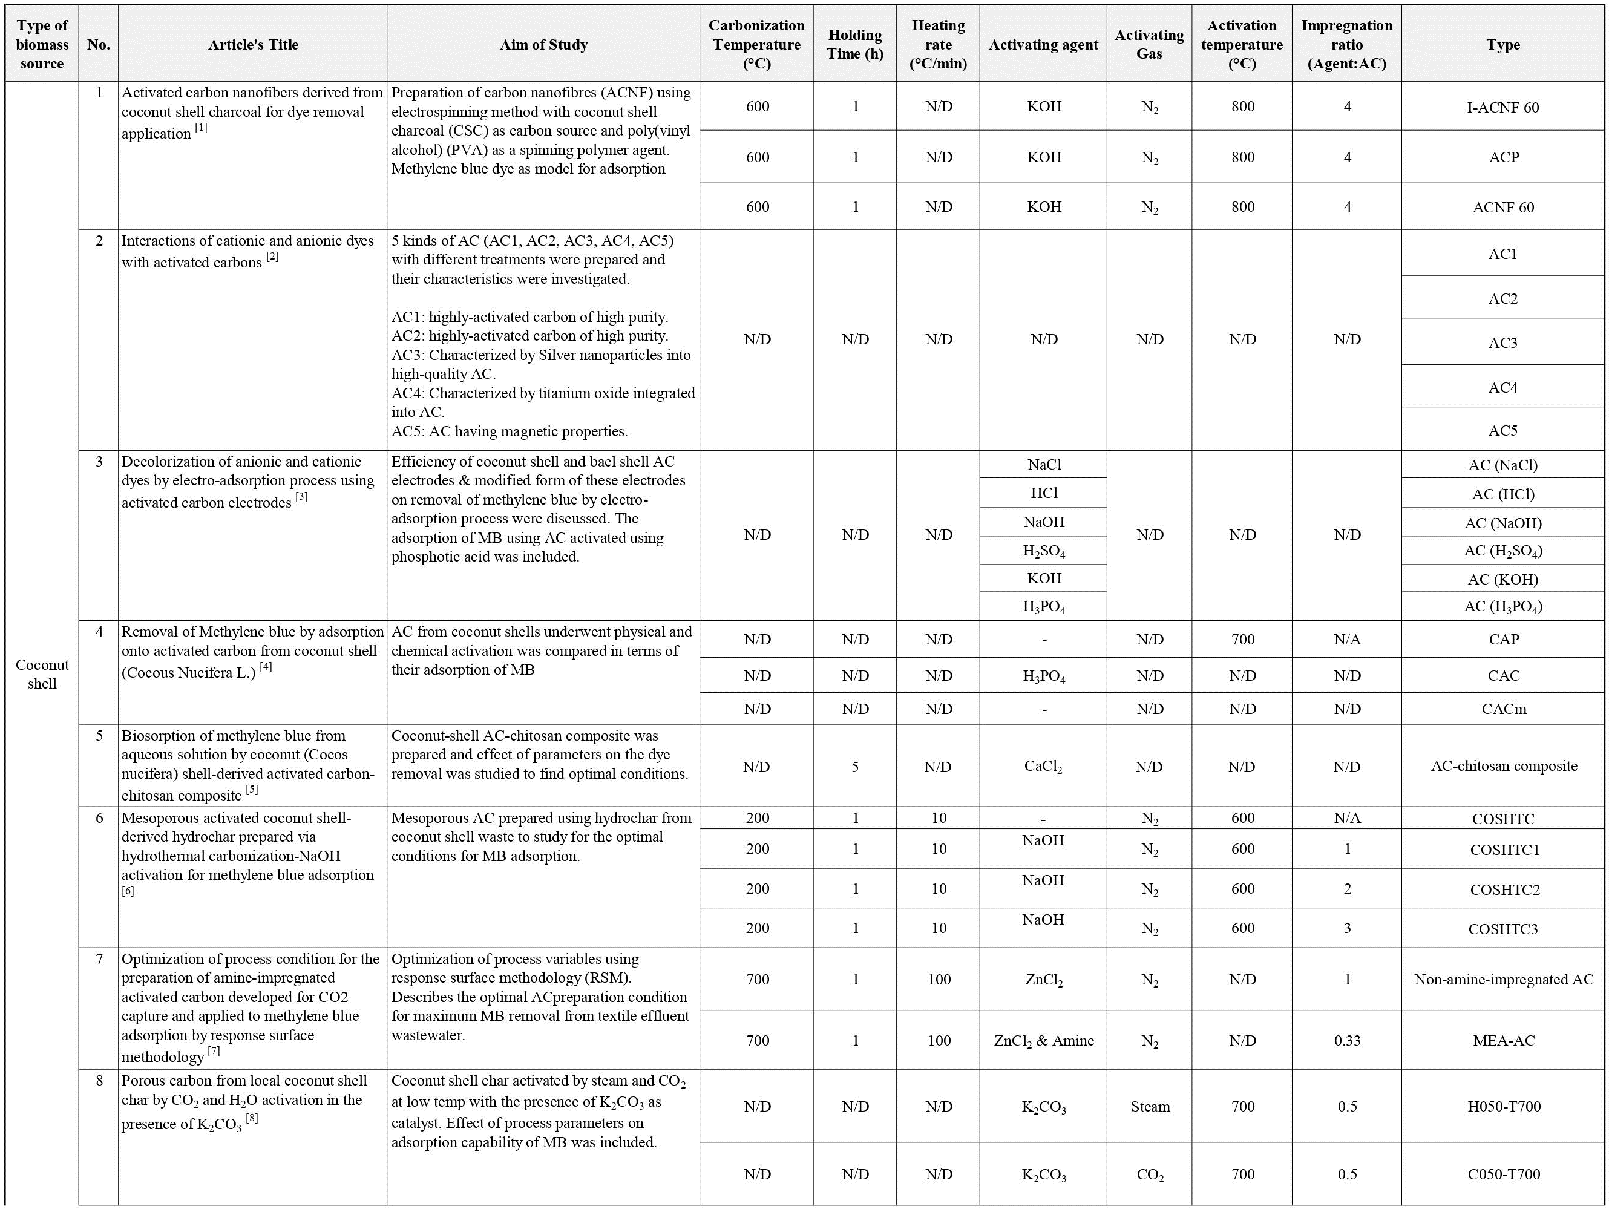
Table S1(a): Extracted Data (Synthesis Conditions) for Coconut Shell ACs (cont.)
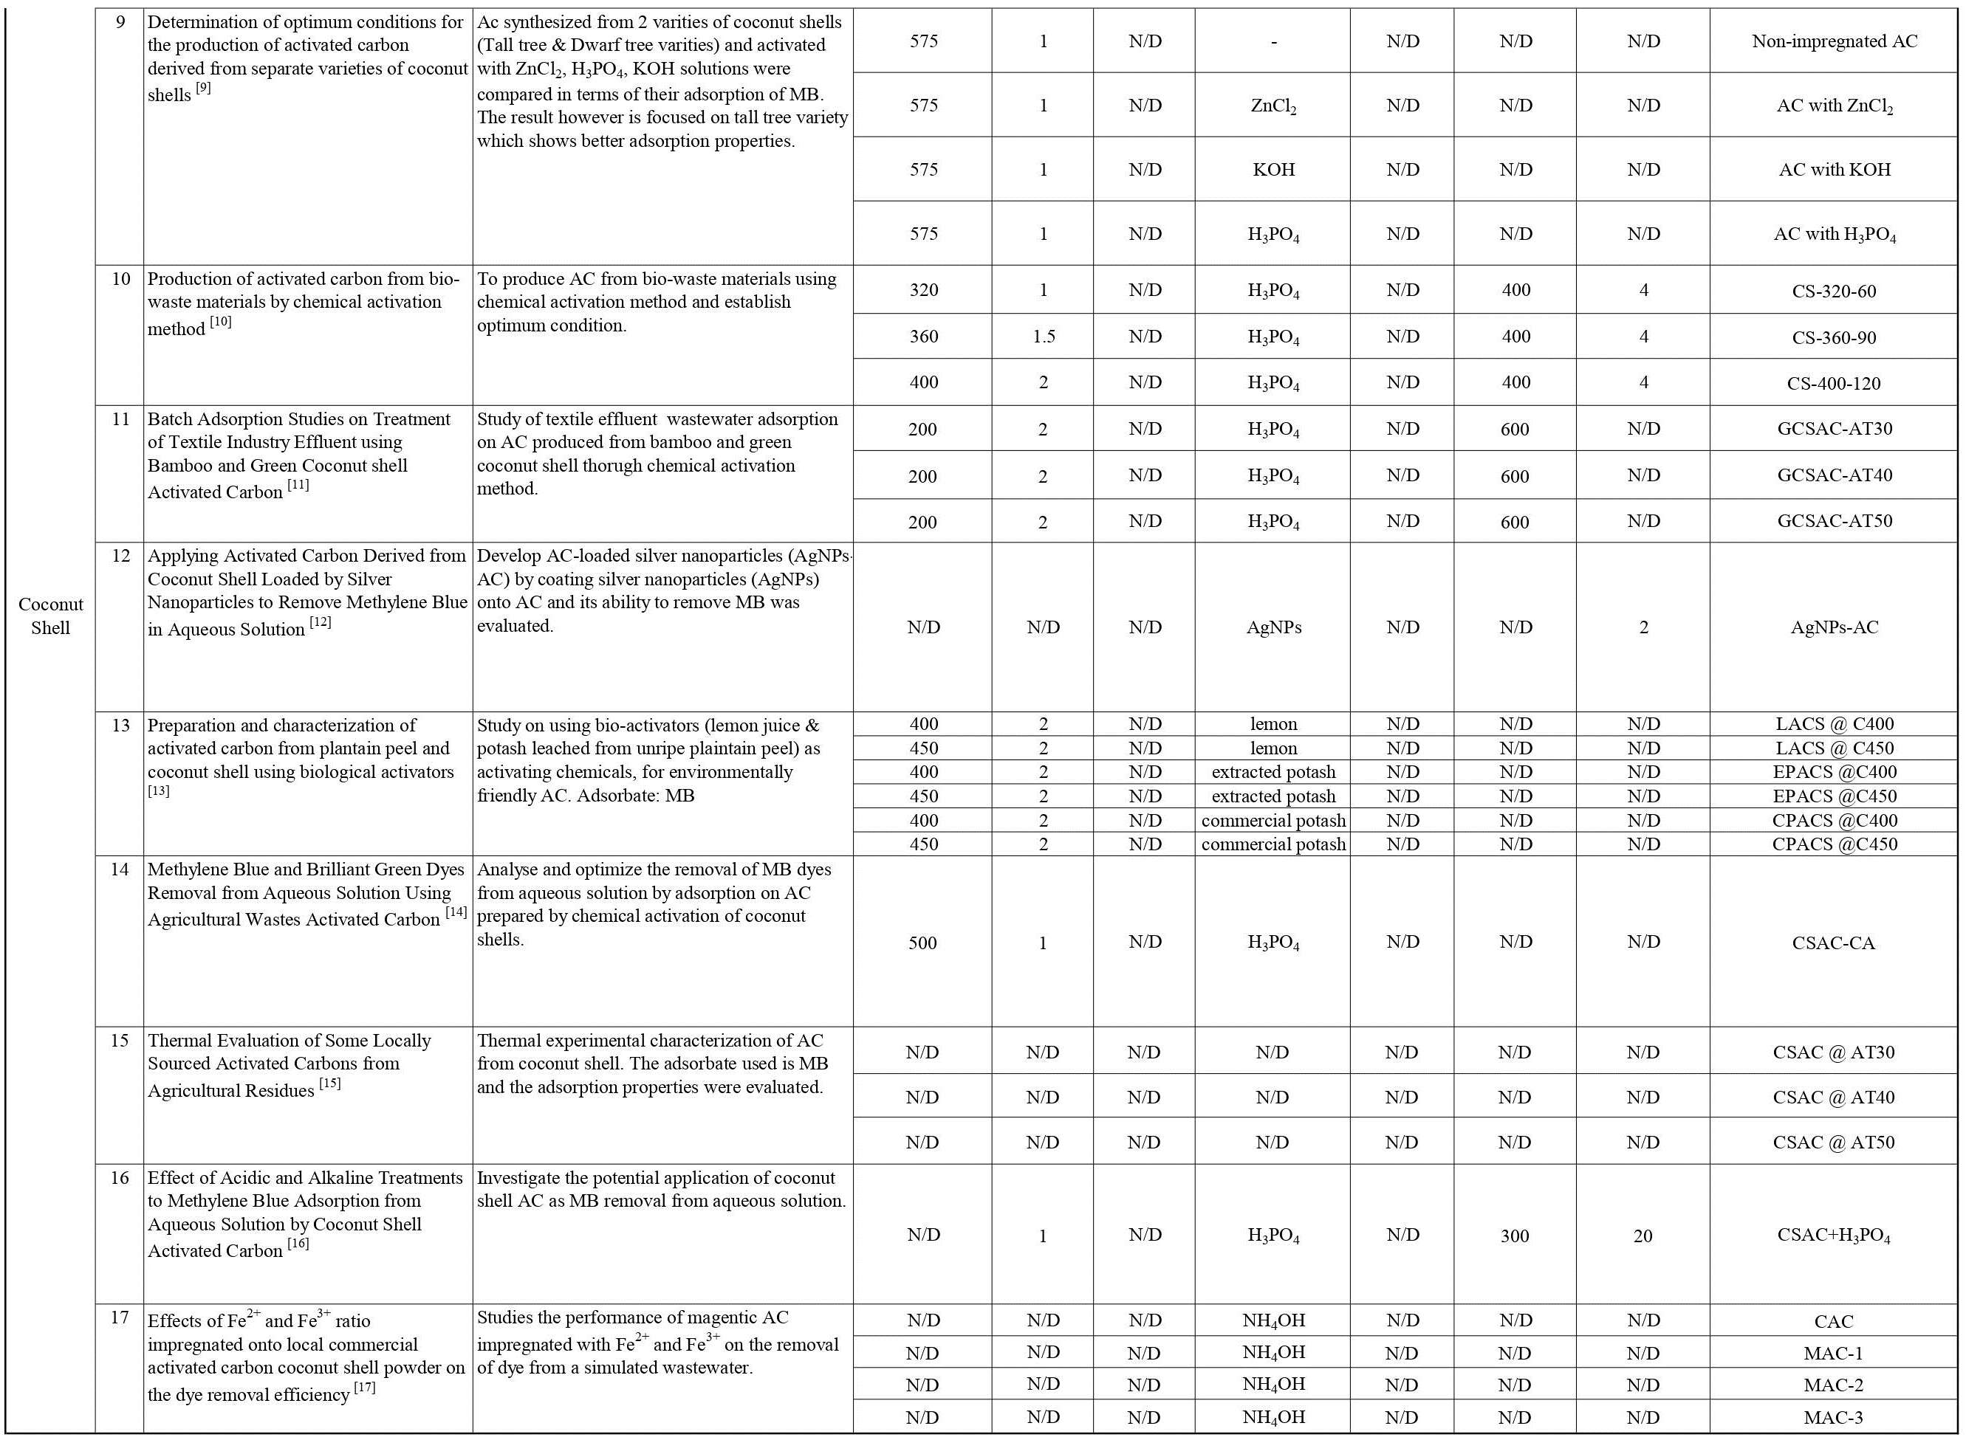

Table S1(b): Extracted Data (Physicochemical Properties) for Coconut Shell ACs

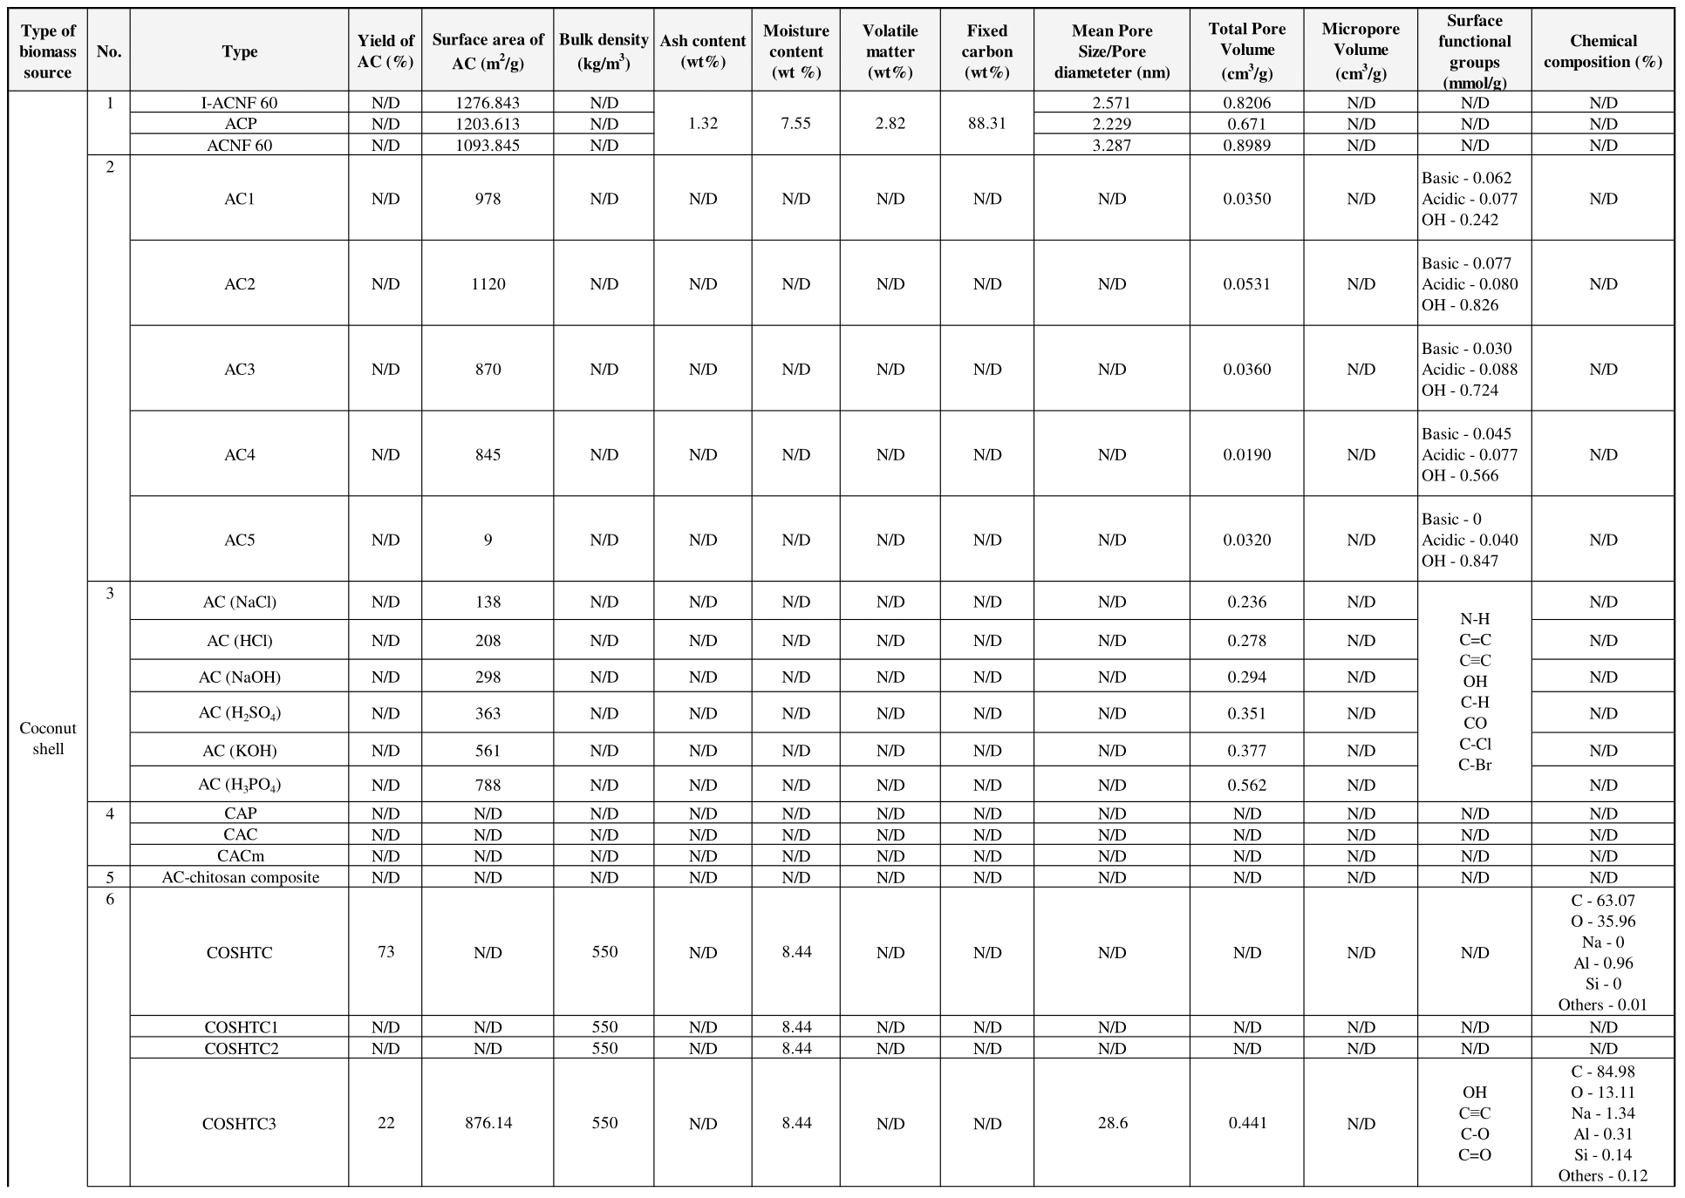

Table S1(b): Extracted Data (Physicochemical Properties) for Coconut Shell ACs (cont.)
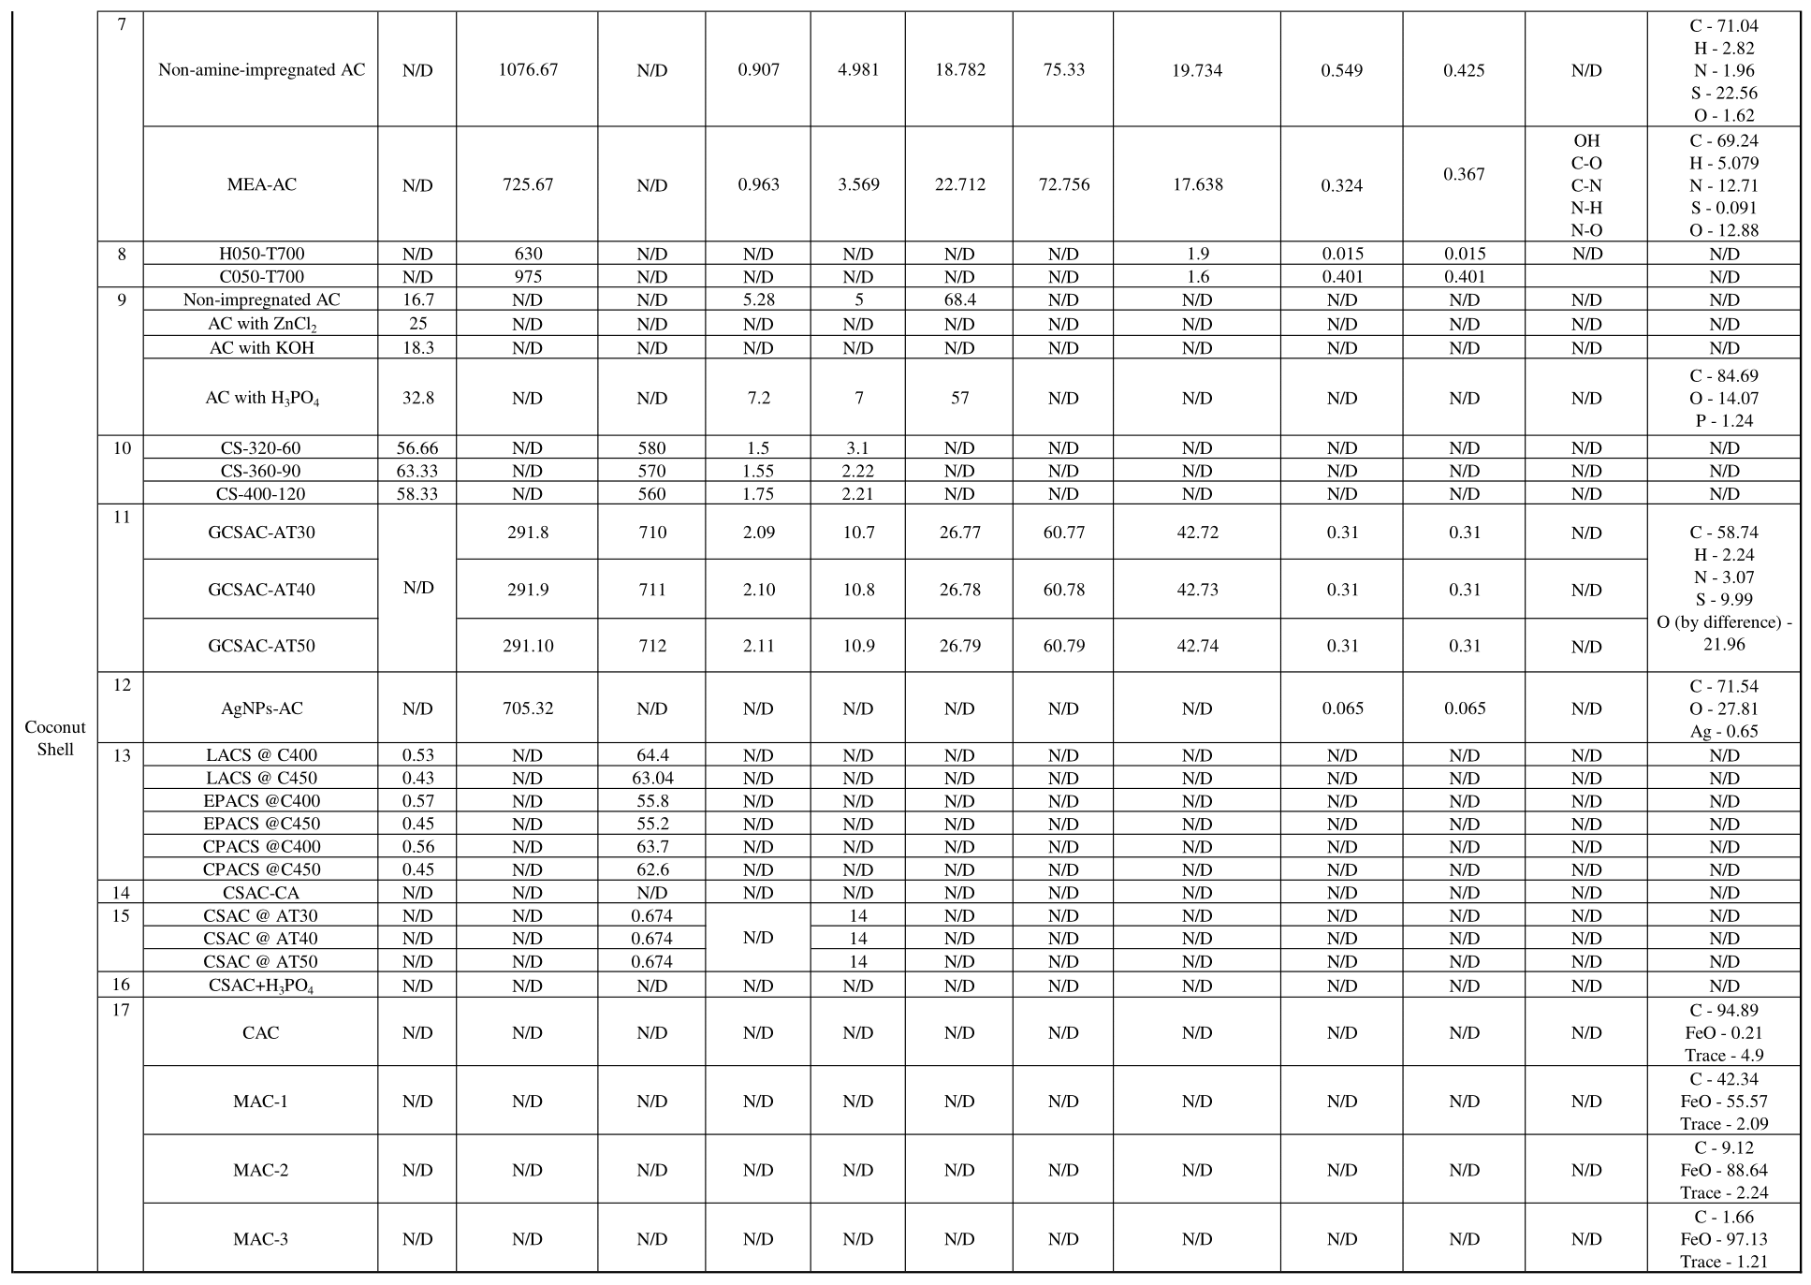

Table S1(c): Extracted Data (Adsorption Performance) for Coconut Shell ACs
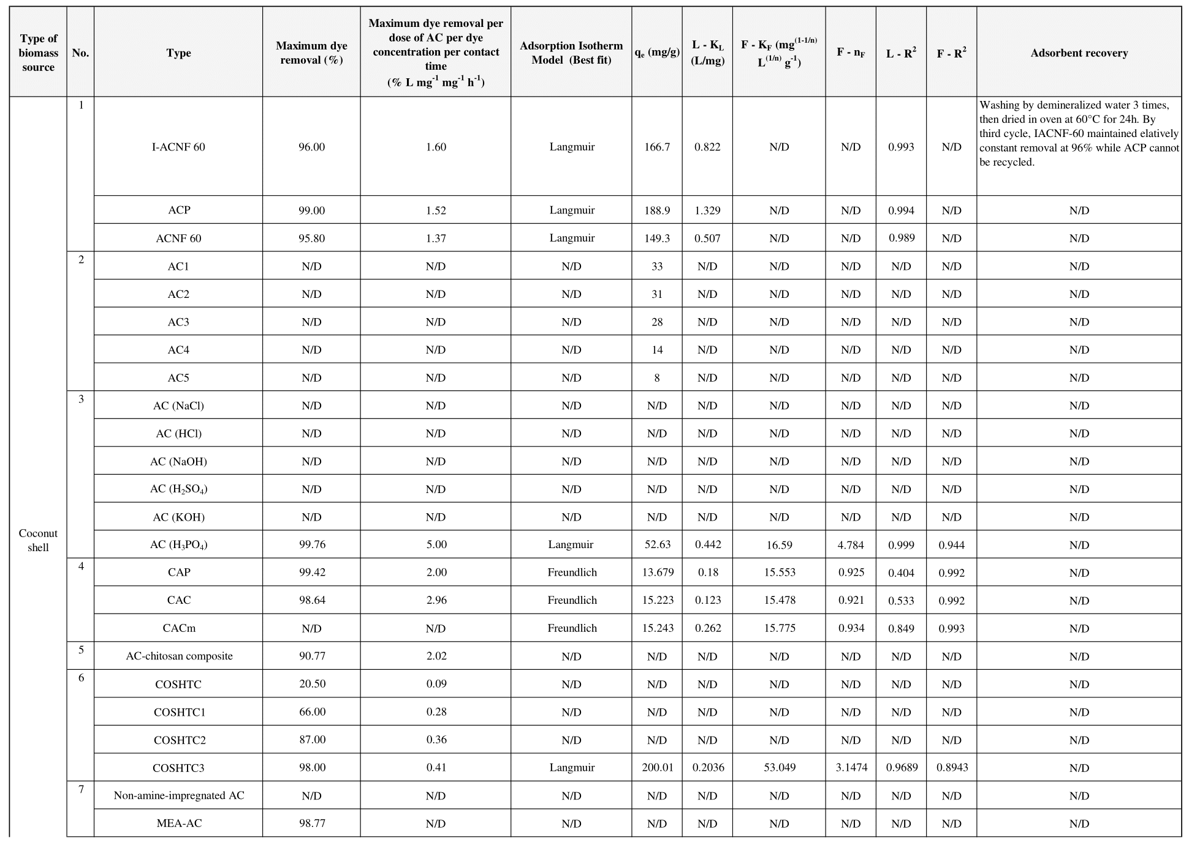

Table S1(c): Extracted Data (Adsorption Performance) for Coconut Shell ACs (cont.)
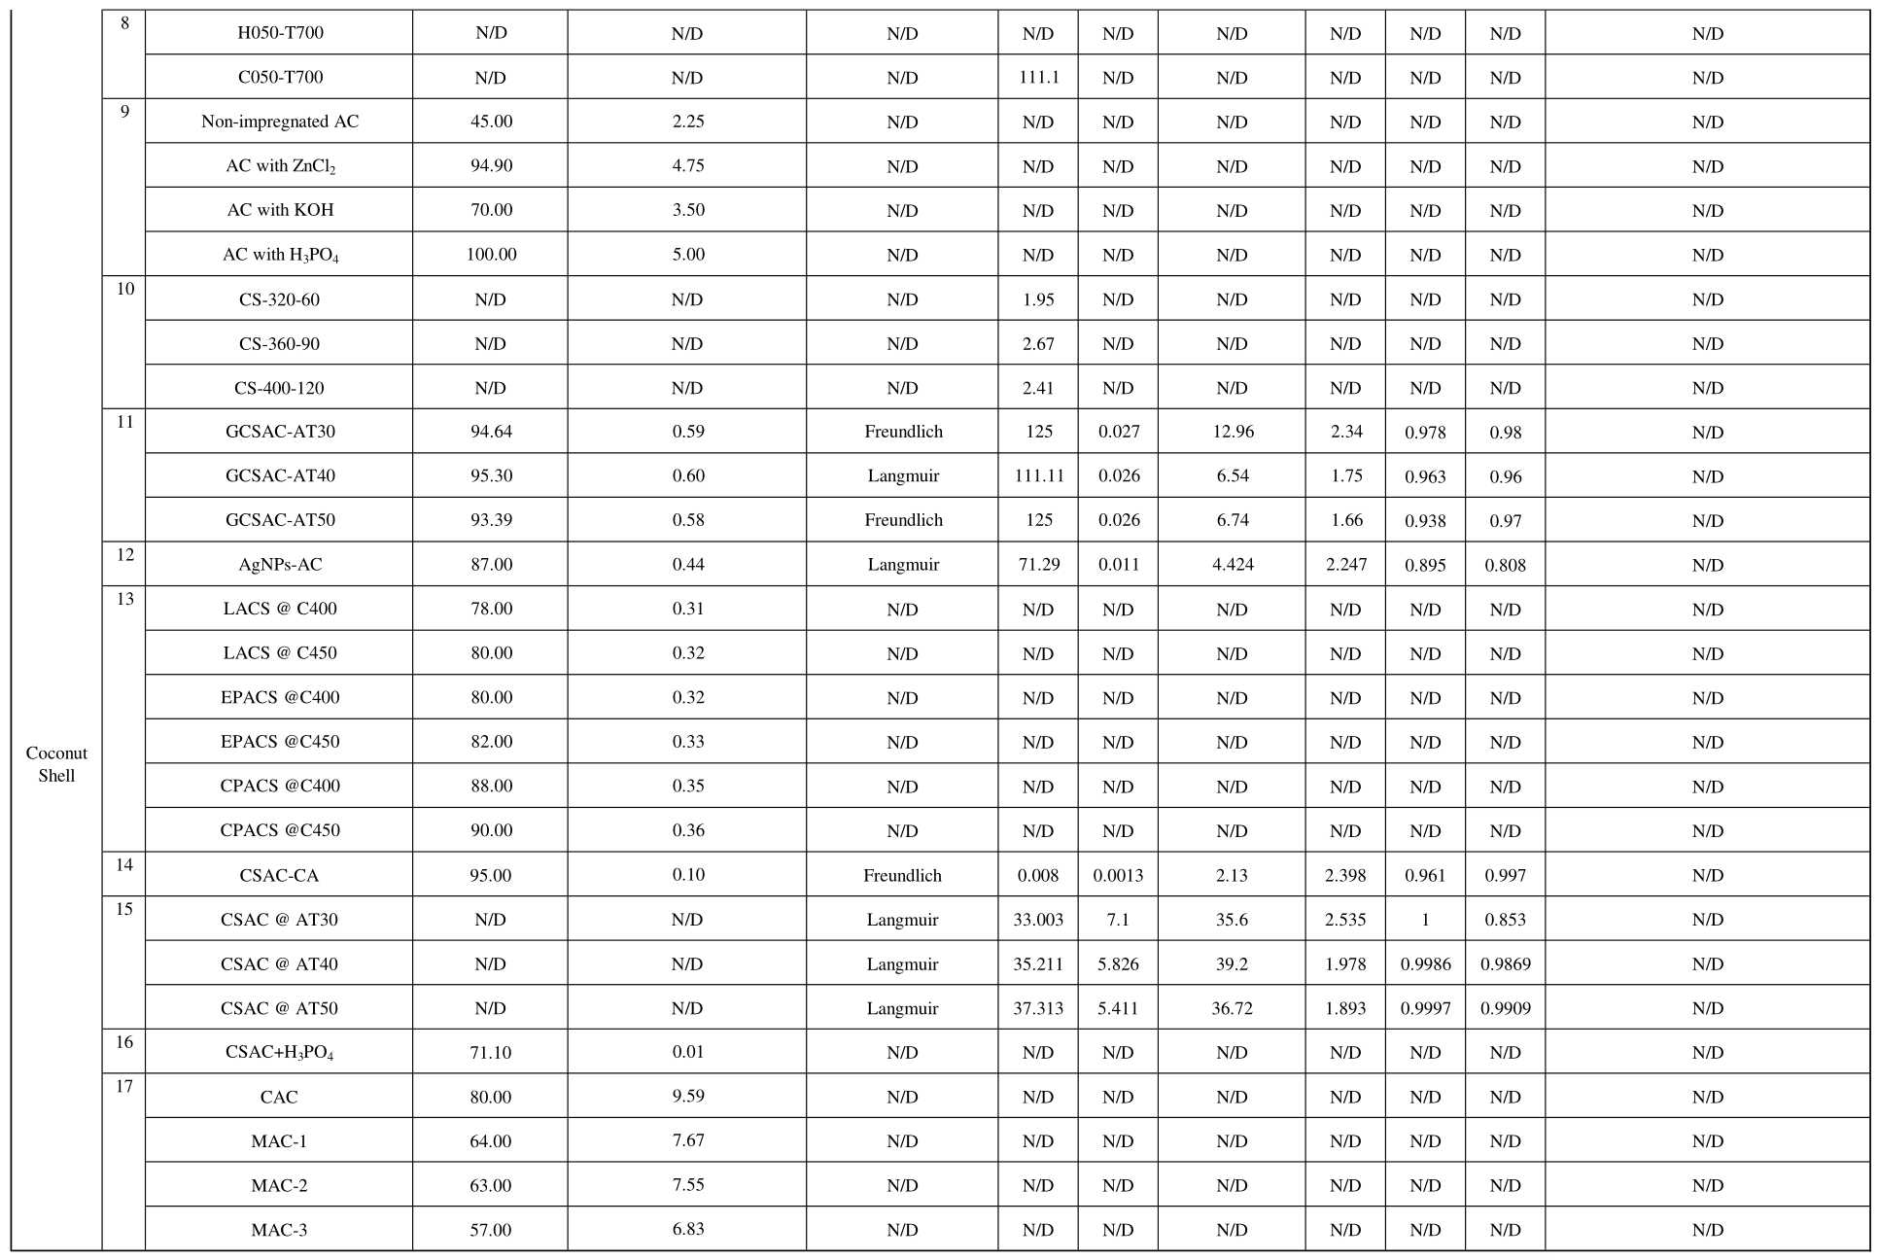

Table S1(d): Extracted Data (Adsorption Conditions) for Coconut Shell ACs
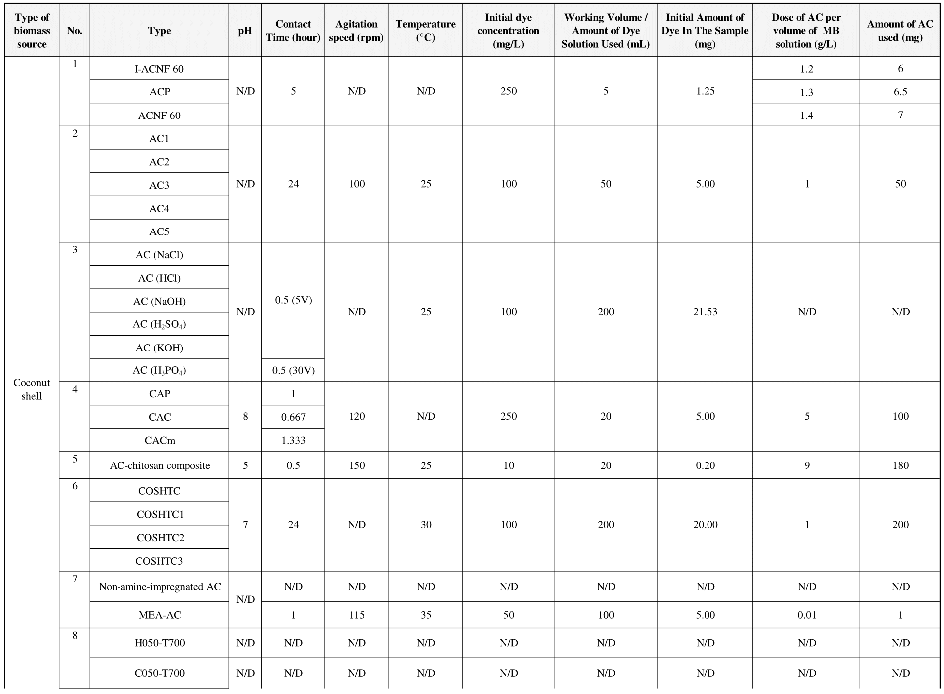

Table S1(d): Extracted Data (Adsorption Conditions) for Coconut Shell ACs (cont.)
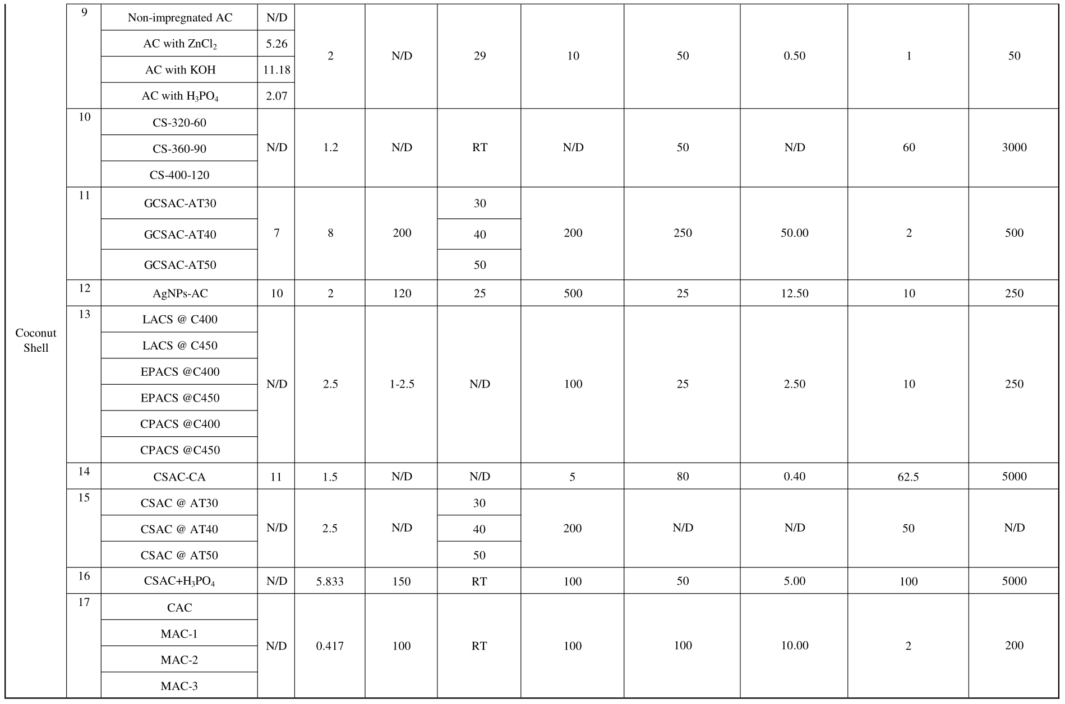

Table S2(a): Extracted Data (Synthesis Conditions) for Bamboo ACs
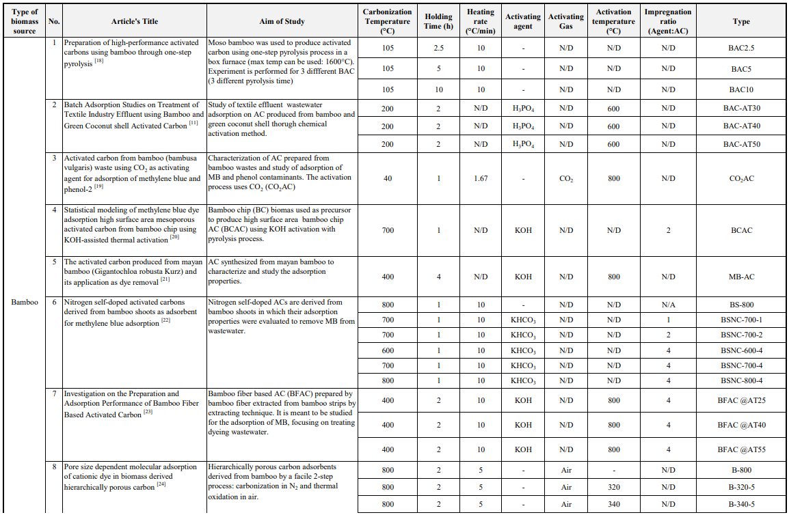

Table S2(a): Extracted Data (Synthesis Conditions) for Bamboo ACs (cont.)
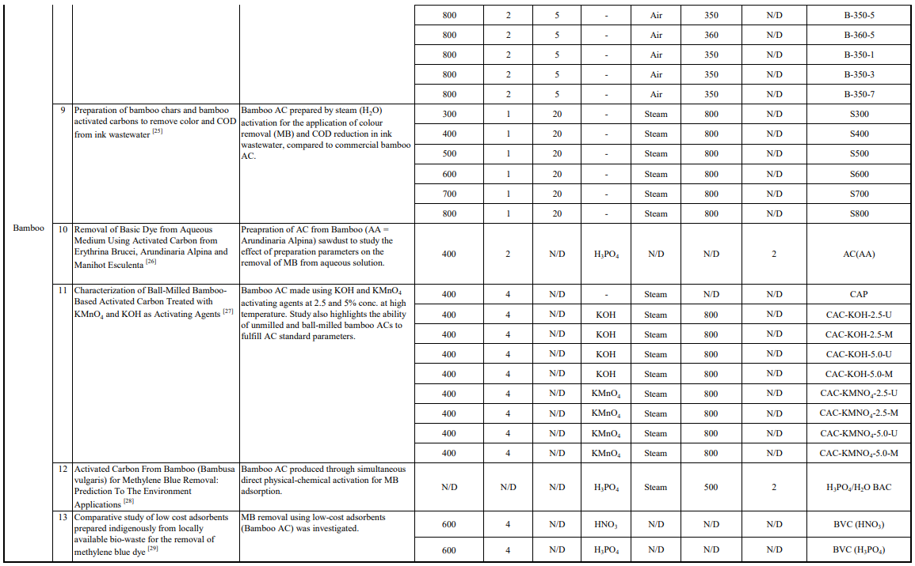

Table S2(b): Extracted Data (Physicochemical Properties) for Bamboo ACs
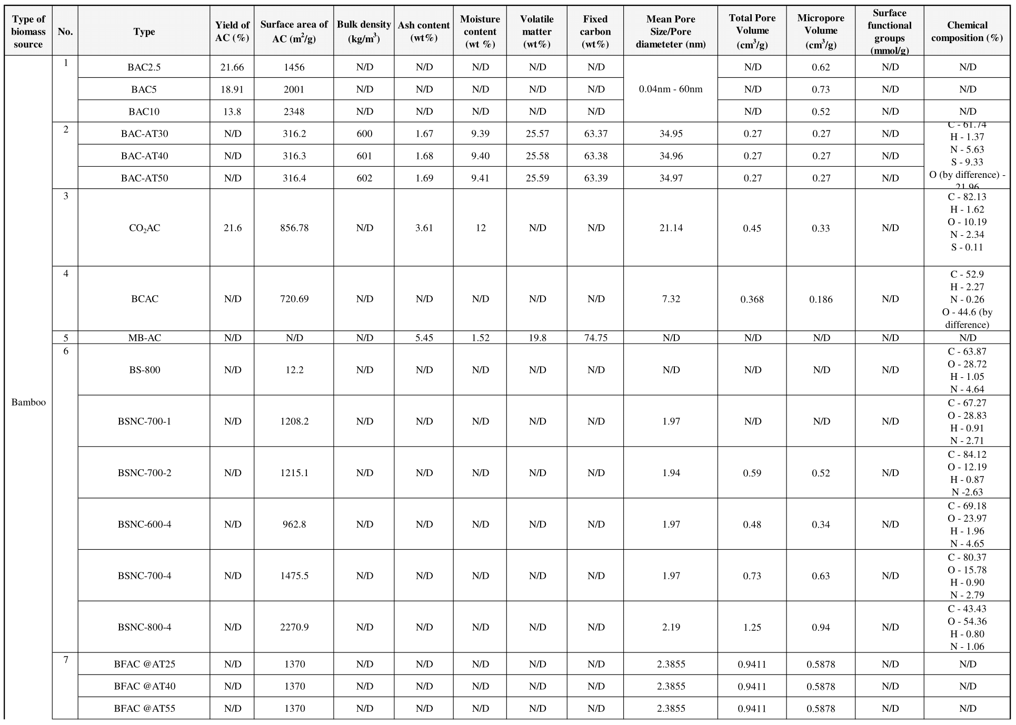

Table S2(b): Extracted Data (Physicochemical Properties) for Bamboo ACs (cont.)
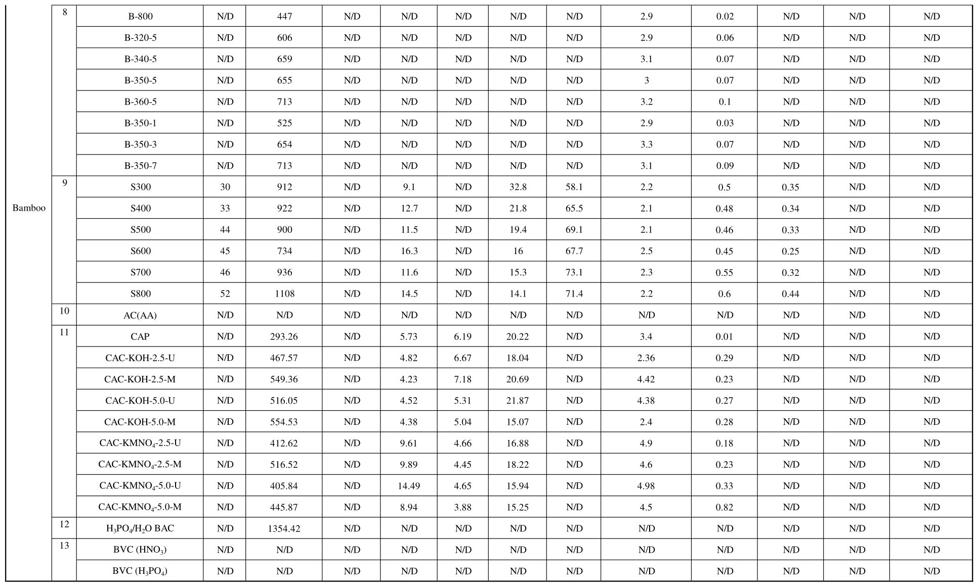

Table S2(c): Extracted Data (Adsorption Performance) for Bamboo ACs
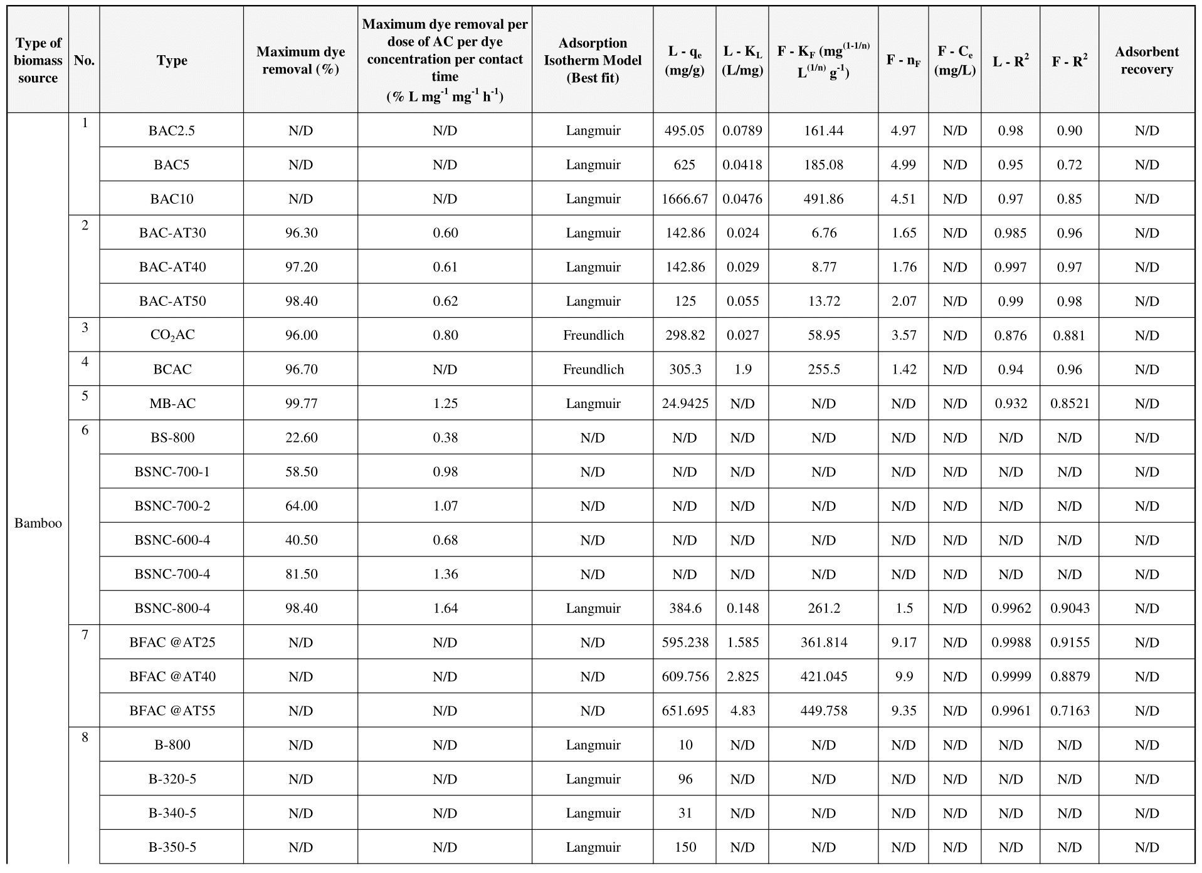
Table S2(c): Extracted Data (Adsorption Performance) for Bamboo ACs (cont.)
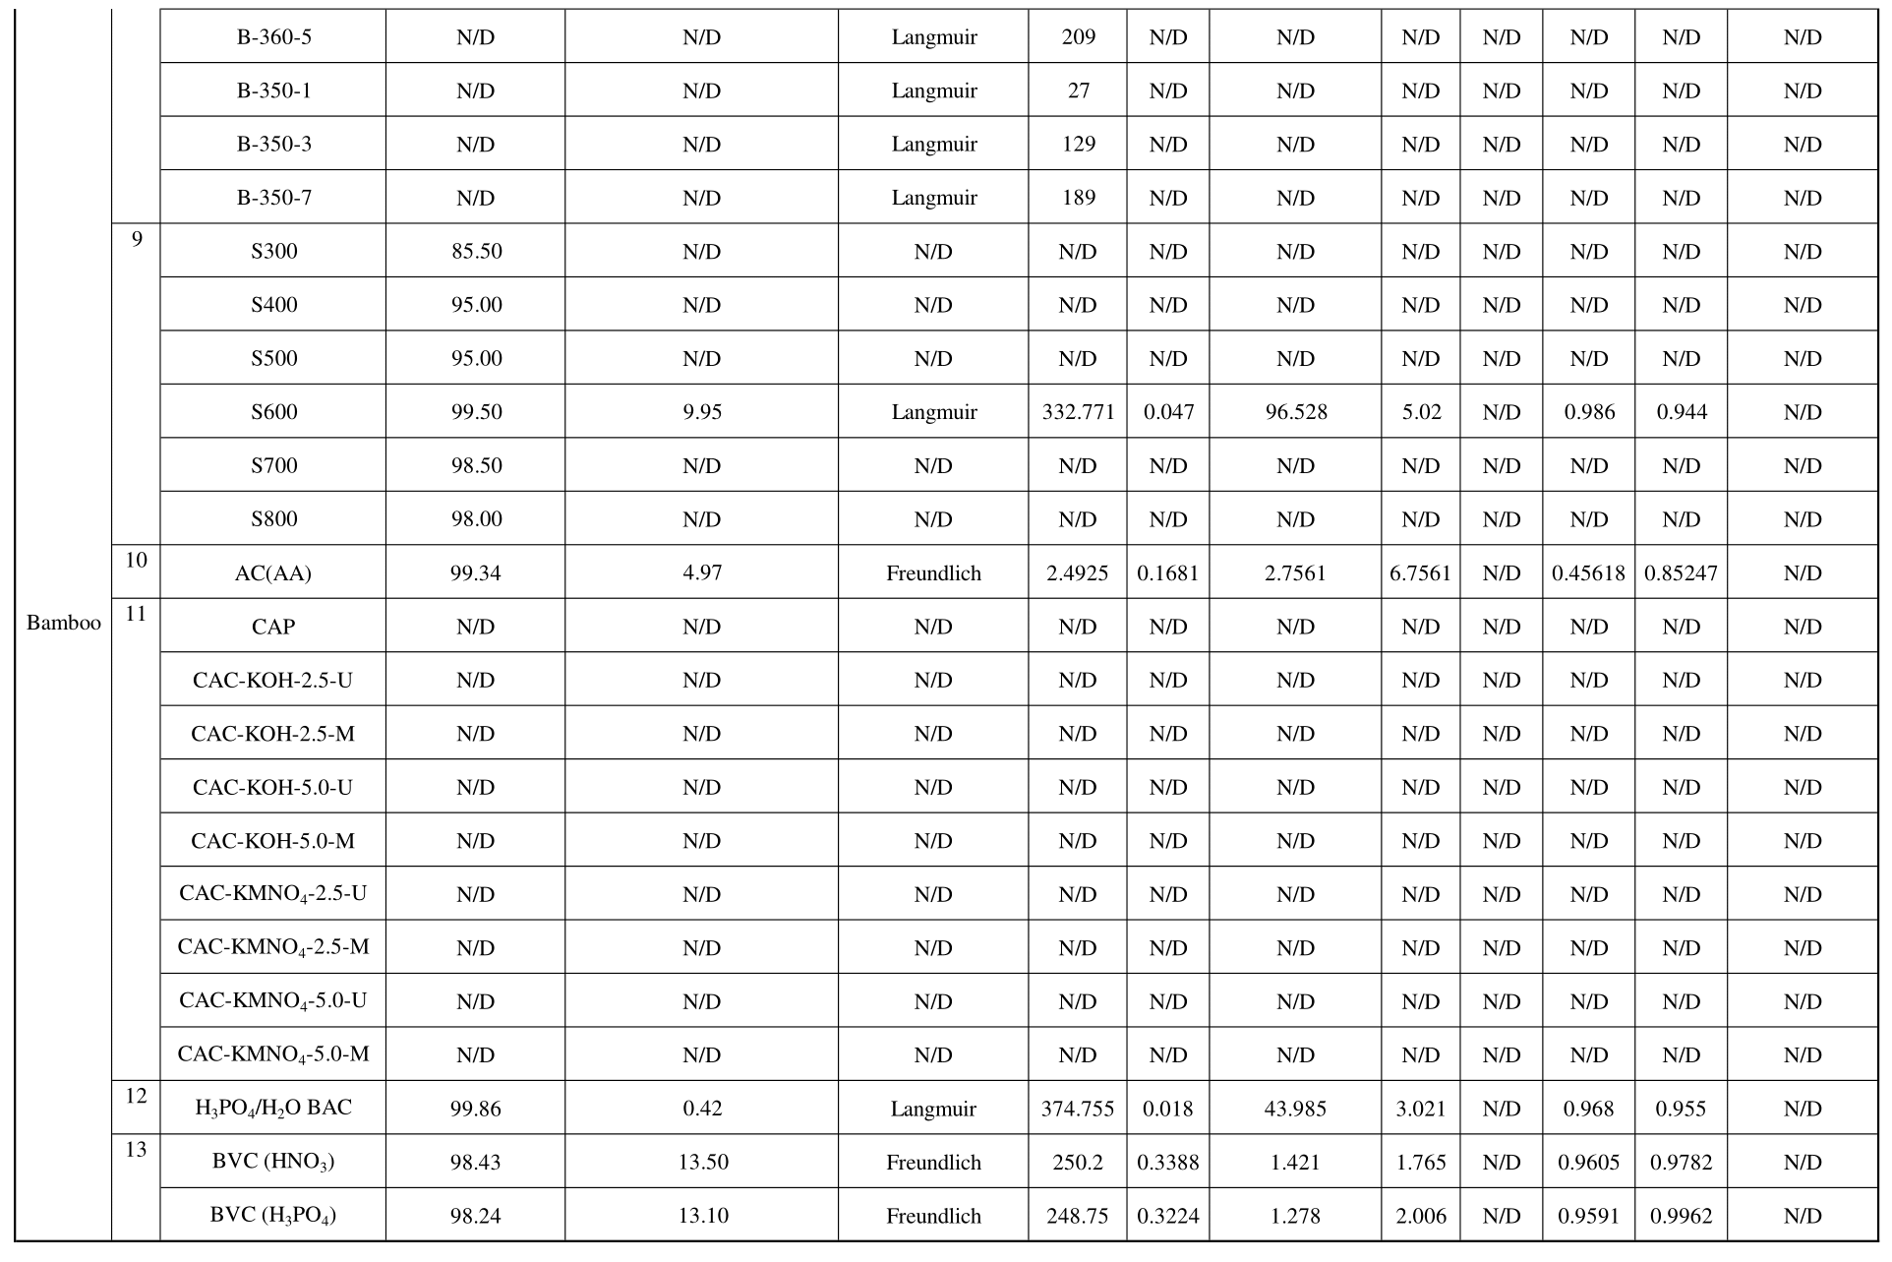

Table S2(d): Extracted Data (Adsorption Conditions) for Bamboo ACs
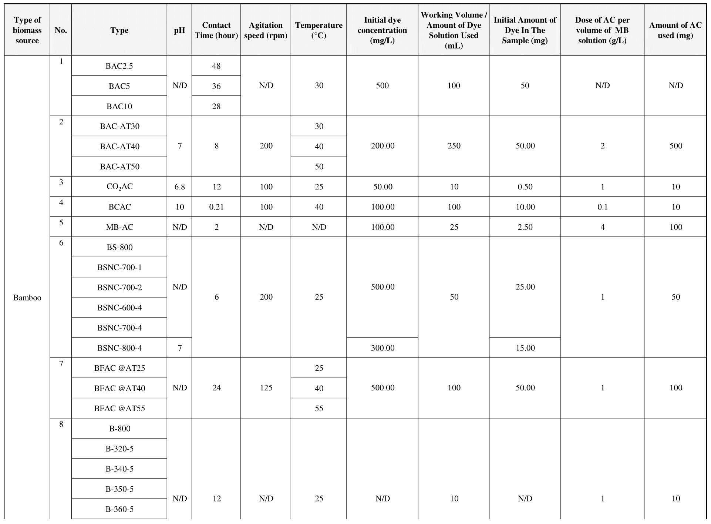
Table S2(d): Extracted Data (Adsorption Conditions) for Bamboo ACs (cont.)
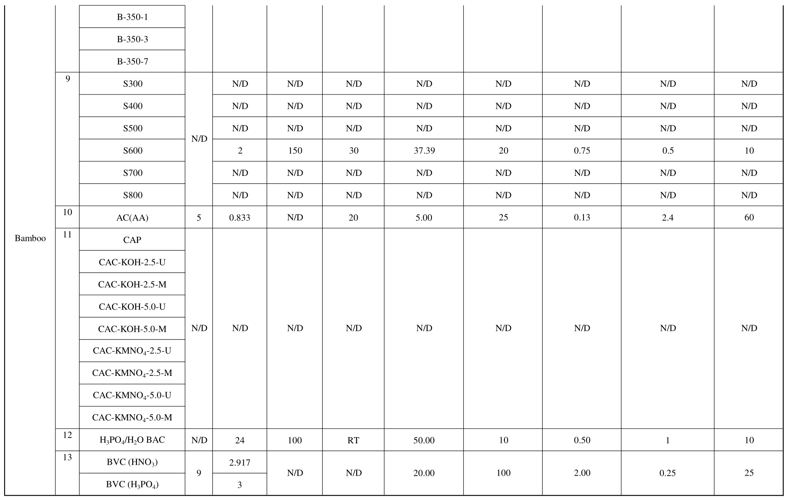

Table S3(a): Extracted Data (Synthesis Conditions) for Rice Husk ACs
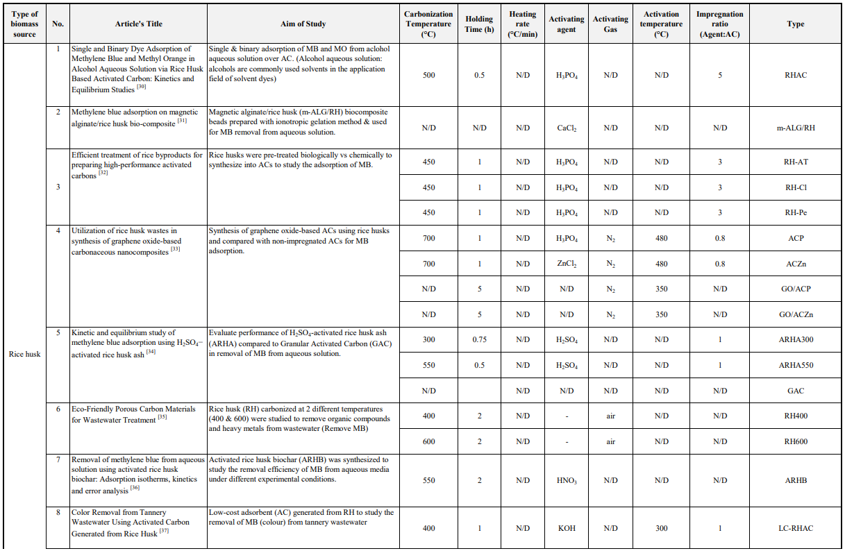

Table S3(a): Extracted Data (Synthesis Conditions) for Rice Husk ACs (cont.)
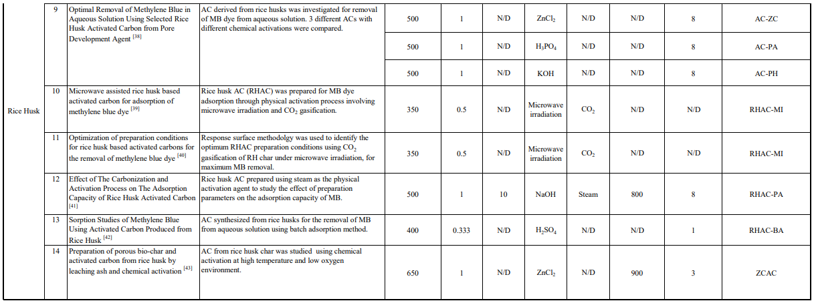

Table S3(b): Extracted Data (Physicochemical Properties) for Rice Husk ACs
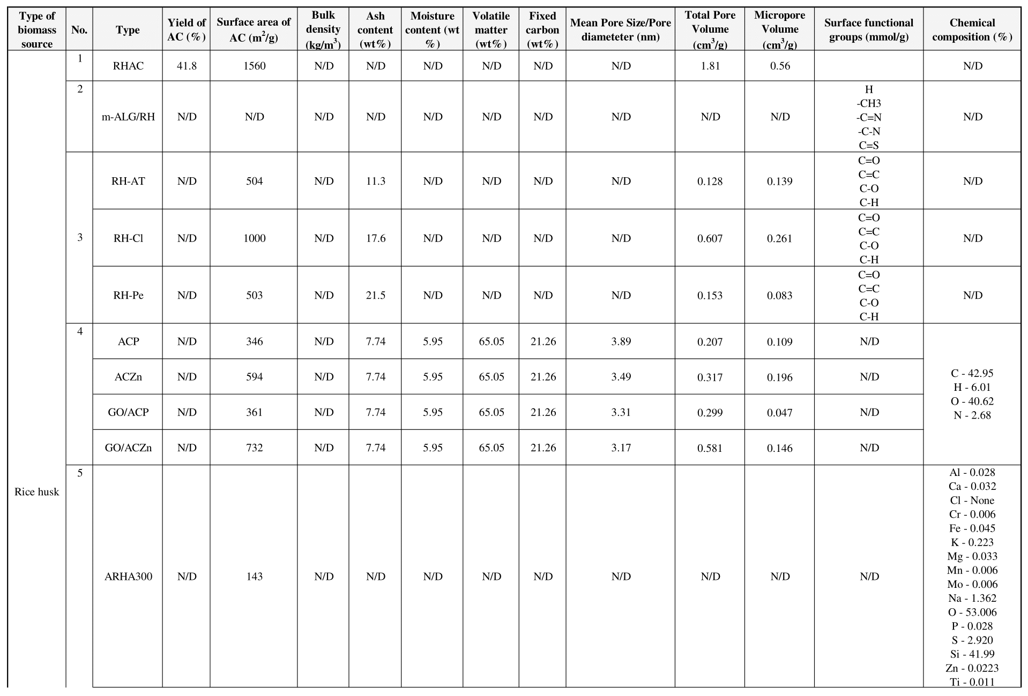

Table S3(b): Extracted Data (Physicochemical Properties) for Rice Husk ACs (cont.)
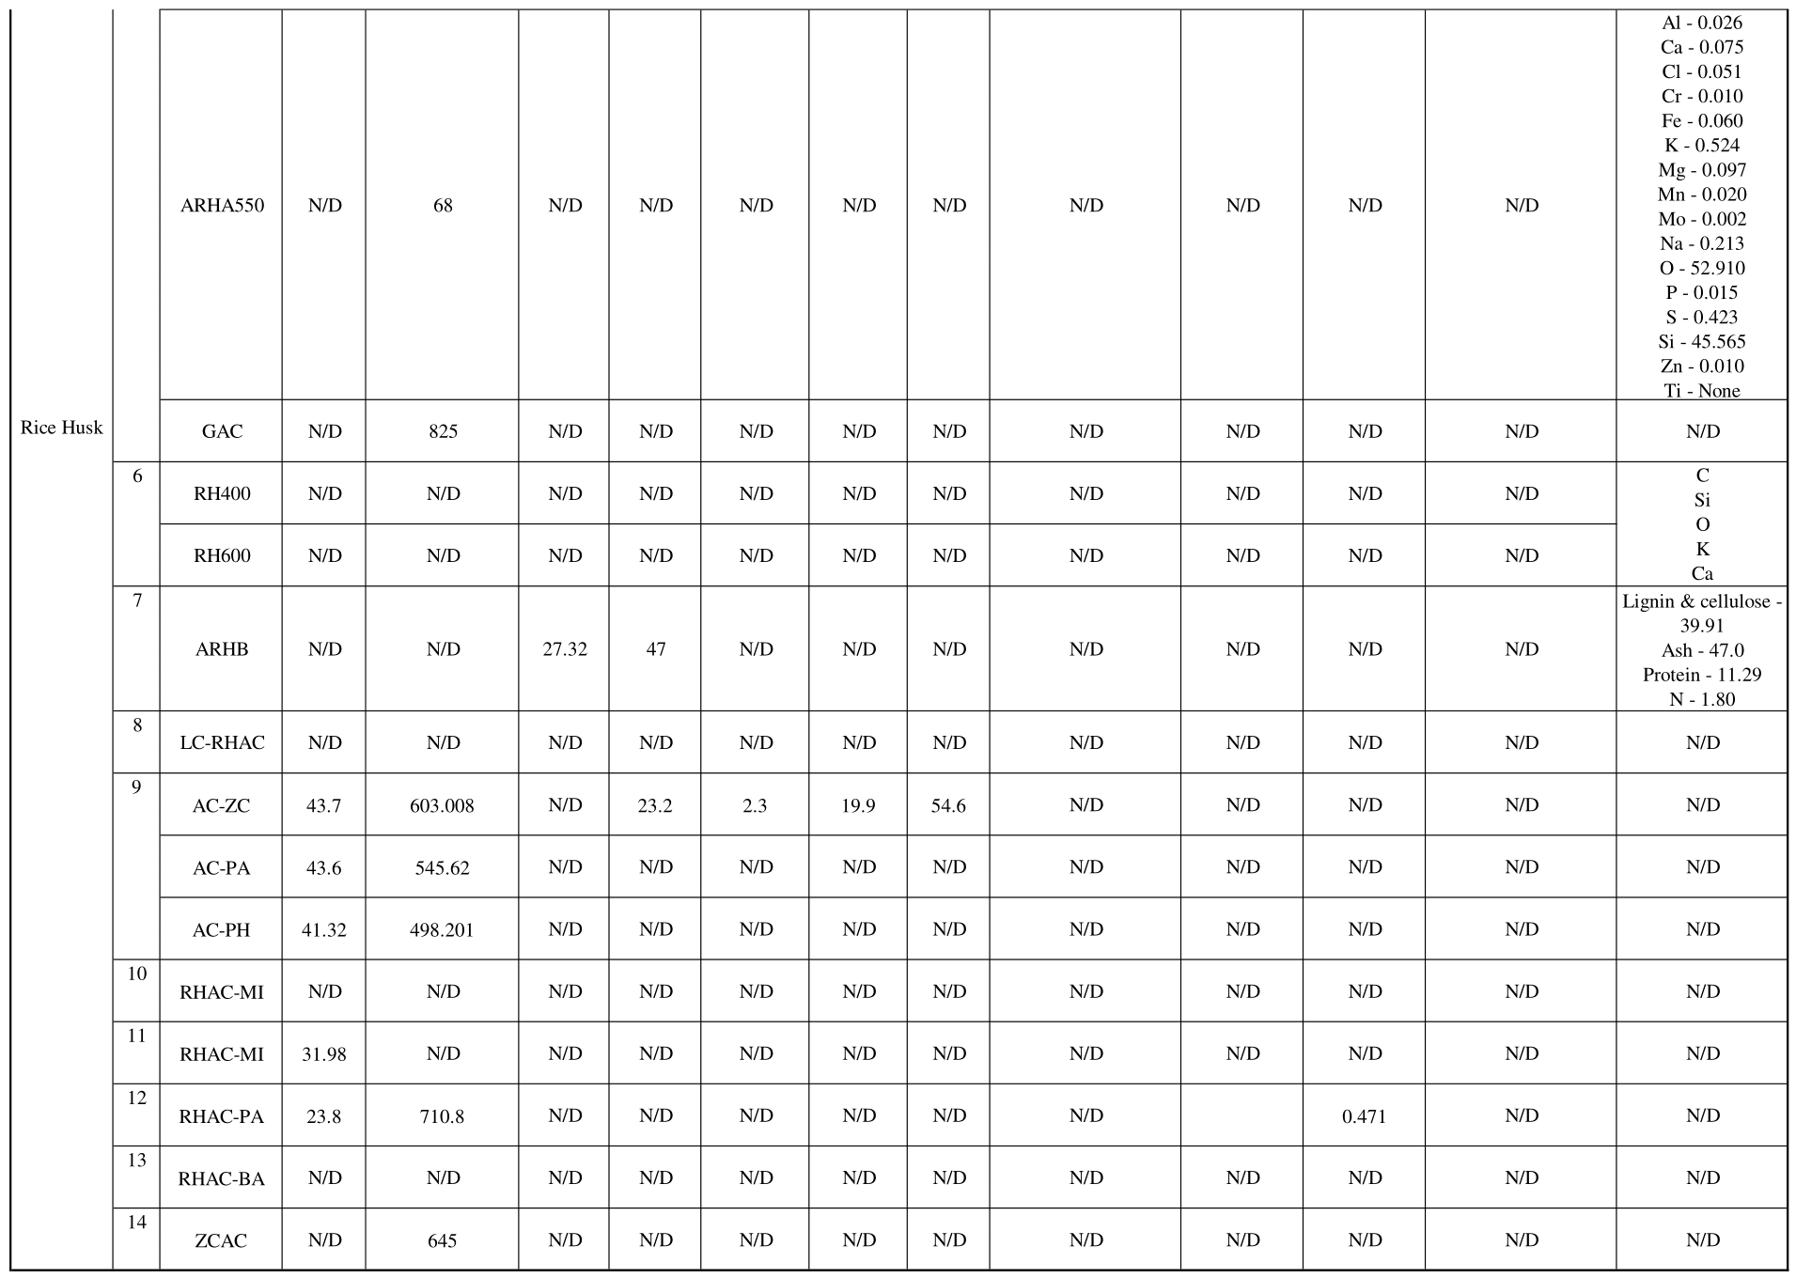
Table S3(c): Extracted Data (Adsorption Performance) for Rice Husk ACs
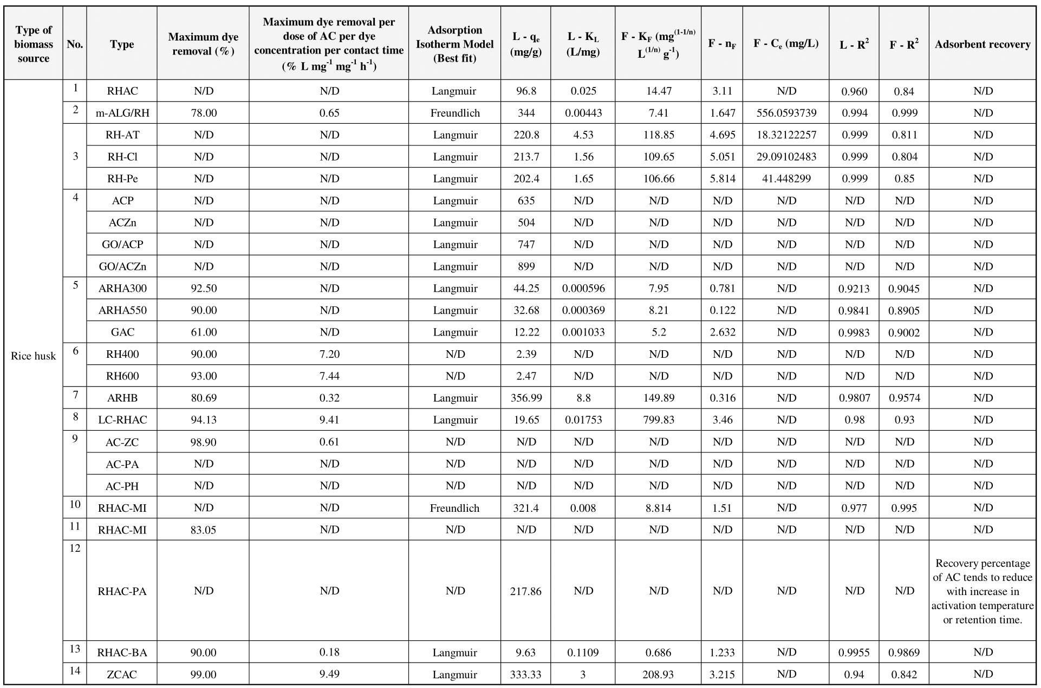

Table S3(c): Extracted Data (Adsorption Conditions) for Rice Husk ACs
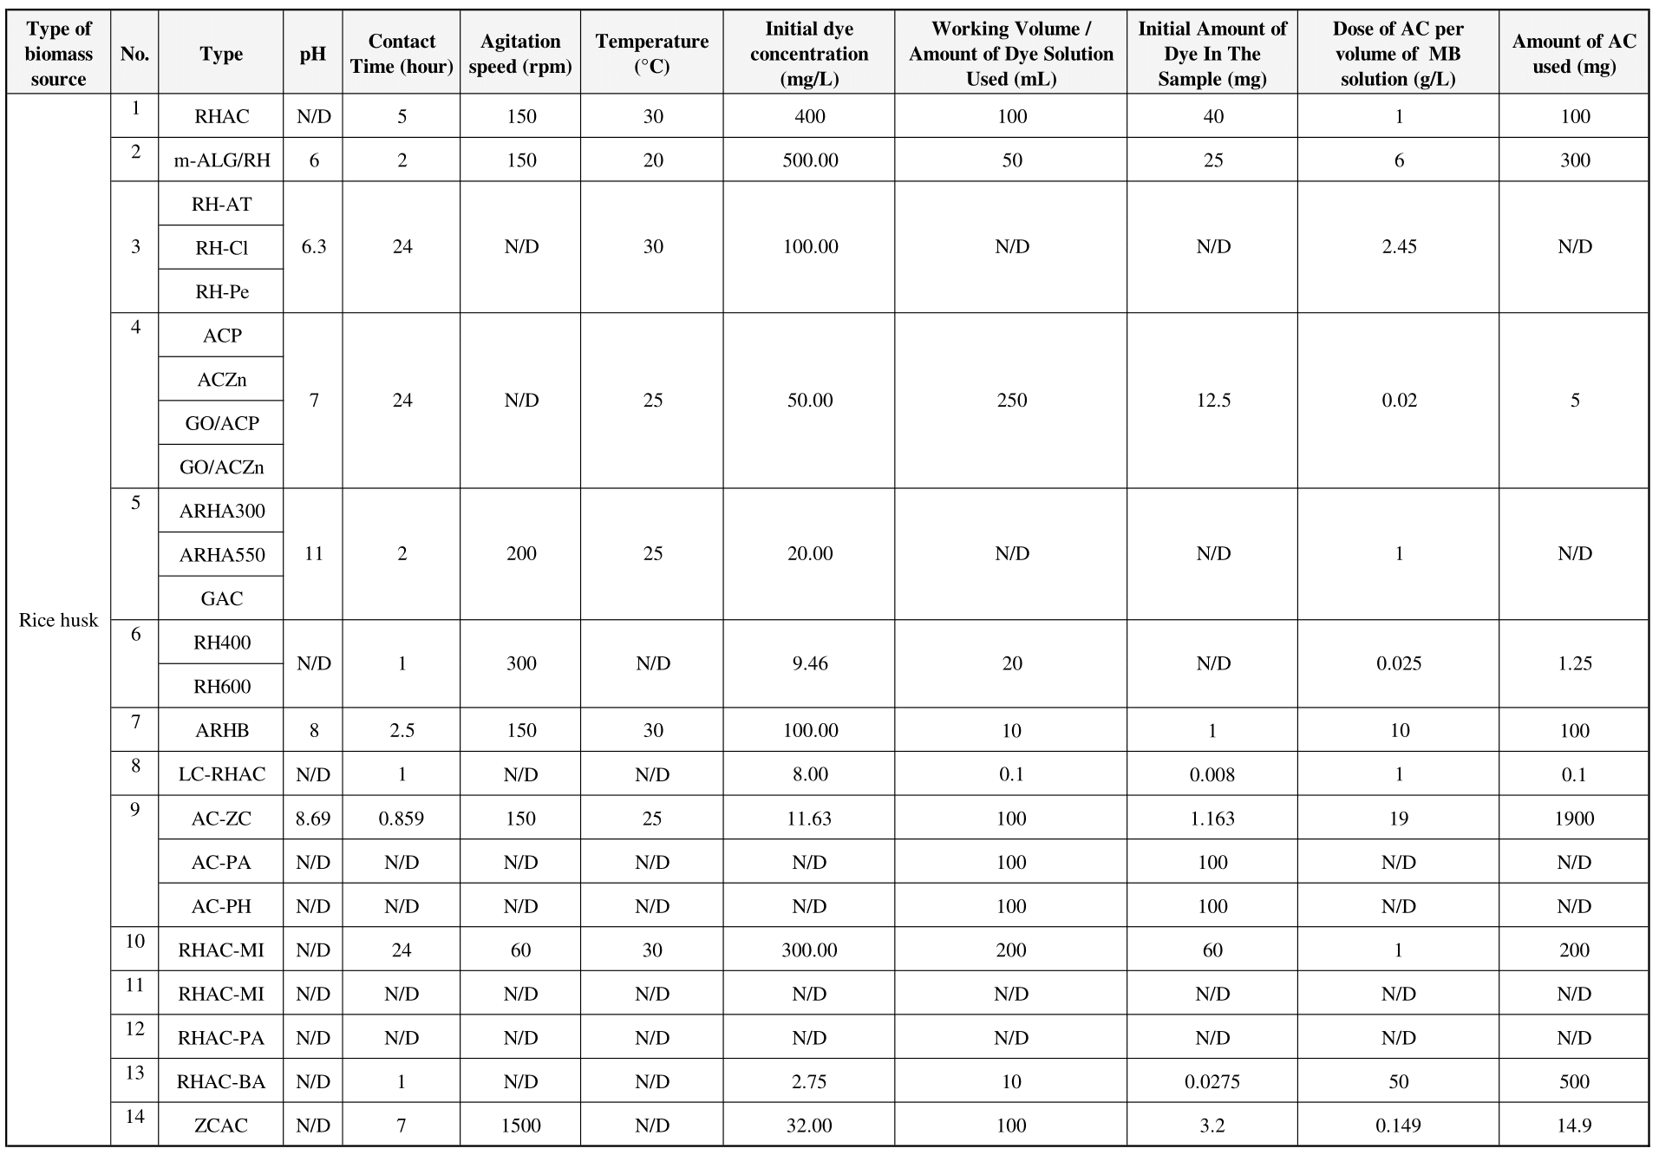

REFRENCES:

- Widiyastuti, W., Fahrudin Rois, M., Suari, N. M. I. P., Setyawan, H., Activated carbon nanofibers derived from coconut shell charcoal for dye removal application. Adv. Powder Technol. 2020, 31(8), 3267–3273.
- Ogata, F., Yasuda, S., Saenjum, C., Nakamura, T., Kawasaki, N., Interactions of cationic and anionic dyes with activated carbons. E-J. Surf. Sci. and Nanotechnol. 2020, 18, 269–274.
- Nainamalai, M., Palani, M., Allwin Ebinesar, J. S. S., Bhuvaneshwari, S., Decolorization of anionic and cationic dyes by electro-adsorption process using activated carbon electrodes. Indian J. Chem. 2019, 26(4), 300–311.
- Khuluk, R. H., Rahmat, A., Buhani, B., Removal of methylene blue by adsorption onto activated carbon from coconut shell (Cocous Nucifera L.). Indones. J. Sci. and Technol. 2019, 4(2), 229–240.
- Regunton, P. C. V., Sumalapao, D. E. P., Villarante, N. R., Biosorption of methylene blue from aqueous solution by coconut (Cocos nucifera) shell-derived activated carbon-chitosan composite. Orient. J. of Chem. 2018, 34(1), 115–124.
- Islam, M. A., Ahmed, M. J., Khanday, W. A., Asif, M., Hameed, B. H., Mesoporous activated coconut shell-derived hydrochar prepared via hydrothermal carbonization-NaOH activation for methylene blue adsorption. J. Environ. Manage. 2017, 203, 237–244.
- Das, D., Meikap, B. C., Optimization of process condition for the preparation of amine-impregnated activated carbon developed for CO₂ capture and applied to MB adsorption by response surface methodology. J. Environ. Sci. Health A 2017, 52(12), 1164–1172.
- Vi, N. N. T., Truyen, D. H., Trung, B. C., An, N. T., Van Dung, N., Long, N. Q., Porous carbon from local coconut shell char by CO₂ and H₂O activation in the presence of K₂CO₃. AIP Conf. Proc. 2017, 1878.
- Sanni, E. S., Emetere, M. E., Odigure, J. O., Efeovbokhan, V. E., Agboola, O., Sadiku, E. R., Determination of optimum conditions for the production of activated carbon derived from separate varieties of coconut shells. Int. J. Chem. Eng. 2017. 2801359.
- Yasin, J., & Pravinkumar, R., Production of activated carbon from bio-waste materials by chemical activation method. AIP Conf. Proc. 2020, 2225.
- Bokil, S. A., Topare, N. S., Khedkar, S. V., Batch Adsorption Studies on Treatment of Textile Industry Effluent using Bamboo and Green Coconut shell Activated Carbon. IOP Conf. Ser.: Mater. Sci. Eng. 2020, 983, 012005.
- Van, H. T., Nguyen, T. M. P., Thao, V. T., Vu, X. H., Nguyen, T. V., Nguyen, L. H., Applying Activated Carbon Derived from Coconut Shell Loaded by Silver Nanoparticles to Remove Methylene Blue in Aqueous Solution. Water Air Soil Pollut. 2018, 229, 393.
- Efeovbokhan, V. E., Alagbe, E. E., Odika, B., Babalola, R., Oladimeji, T. E., Abatan, O. G., Yusuf, E. O., Preparation and characterization of activated carbon from plantain peel and coconut shell using biological activators. J. Phys. Conf. Ser. 2019, 1378, 032035.
- Ali, A. F., Kovo, A. S., Adetunji, S. A. (2017). Methylene Blue and Brilliant Green Dyes Removal from Aqueous Solution Using Agricultural Wastes Activated Carbon. J. Encapsulation Adsorp. Sci. 2017, 07(02), 95–107.
- Sangotayo, E. O. (2018). Thermal Evaluation of Some Locally Produced Activated Carbon from Agricultural Residue. J. Nat. Sci. Res. 2018, 8(18), 23–31.
- Abdullah, N. H., Inu, I., Razab, M. K. A. A., Noor, A. M., Zaudin, N. A. C., Rasat, M. S. M., Amin, M. F. M., Abdullah, W. N. W., Shukri, N. M., Halim, A. Z. A., Effect of Acidic and Alkaline Treatments to Methylene Blue Adsorption from Aqueous Solution by Coconut Shell Activated Carbon. Int. J. Current Res. Sci. Eng. Technol. 2018, 319–324
- Machdar, I., Faradillasari, C., Khair, N. A., Asnawi, T. M., BC, A. Y., Yunardi, Y., Effects of Fe²⁺ and Fe³⁺ ratio impregnated onto local commercial activated carbon coconut shell powder on the dye removal efficiency. Jurnal Litbang Industri 2018, 8(1), 11–16.
- Ma, X., Smith, L. M., Cai, L., Shi, S. Q., Li, H., Fei, B. Preparation of high-performance activated carbons using bamboo through one-step pyrolysis. BioResources 2019, 14(1), 688–699.
- Santana, G. M., Trugilho, P. F., Da Silva Borges, W. M., Bianchi, M. L., Paes, J. B., Nobre, J. R. C., De Medeiros Morais, R., Activated carbon from bamboo (bambusa vulgaris) waste using CO₂ as activating agent for adsorption of methylene blue and phenol. Ciênc. Florest. 2019, 29(2), 769–778.
- Jawad, A. H., Abdulhameed, A. S., Statistical modeling of MB adsorption by high surface area mesoporous activated carbon from bamboo chip using KOH-assisted thermal activation. Energy Ecol. Environ. 2020, 5(6), 456–469.
- Efiyanti, L., Indrawan, D. A., Hastuti, N., Darmawan, S., The activated carbon produced from mayan bamboo (Gigantochloa robusta Kurz) and its application as dye removal. IOP Conf. Ser.: Mater. Sci. Eng. 2020, 935, 012018.
- Mi, B., Wang, J., Xiang, H., Liang, F., Yang, J., Feng, Z., Zhang, T., Hu, W., Liu, X., Liu, Z., Fei, B., Nitrogen self-doped activated carbons derived from bamboo shoots as adsorbent for methylene blue adsorption. Molecules 2019, 24(16). 3012.
- Zhang, Q., Zeng, Y., Xiao, X., Deng, P., He, Q., Zhang, T., Investigation on the Preparation and Adsorption Performance of Bamboo Fiber Based Activated Carbon. Fibers Polym. 2019, 20(2), 293–301.
- Chen, L., Ji, T., Mu, L., Shi, Y., Wang, H., Zhu, J. (2017). Pore size dependent molecular adsorption of cationic dye in biomass derived hierarchically porous carbon. J. Environ. Manage. 2017, 196, 168–177.
- Hata, M., Amano, Y., Thiravetyan, P., Machida, M., Preparation of Bamboo Chars and Bamboo Activated Carbons to Remove Color and COD from Ink Wastewater. Water Environ. Res. 2015, 88(1), 87–96.
- Tadesse, S., Ambo, D., Removal of Basic Dye from Aqueous Medium Using Activated Carbon from Erythrina Brucei, Arundinaria Alpina and Manihot Esculenta. Food Sci. Qual. Manage. 2019, 86, 19–27.
- Qanytah, Q. Syamsu, K., Fahma, F., Pari, G., Characterization of Ball-Milled Bamboo-Based Activated Carbon Treated with KMnO₄ and KOH as Activating Agents. In BioResources 2020, 15(4), 8303–8322
- Santana, G. M., Lelis, R. C. C., Paes, J. B., Morais, R. de-M., Lopes, C. R., de Lima, C. R., Activated Carbon from Bamboo (Bambusa vulgaris) for Methylene Blue Removal: Prediction to The Environment Applications. Ciênc. Florest. 2018., 1179–1191.
- Kibami, D., Comparative study of low-cost adsorbents prepared indigenously from locally available bio-waste for the removal of methylene blue dye. J. Water Sci. Environ. Technol. 2017, 02, 213–225.
- Li, Y., Pan, B., Miao, H., Xu, H., Liu, X., Shi, G., Single and Binary Dye Adsorption of Methylene Blue and Methyl Orange in Alcohol Aqueous Solution via Rice Husk Based Activated Carbon: Kinetics and Equilibrium Studies. Chem. Res. Chinese U. 2020, 36(6), 1272–1278.
- Alver, E., Metin, A. Ü., Brouers, F. (2020). Methylene blue adsorption on magnetic alginate/rice husk bio-composite. Int. J. Biol. Macromol. 2020, 154, 104–113.
- Basta, A. H., Lotfy, V. F., Hasanin, M. S., Trens, P., El-Saied, H., Efficient treatment of rice byproducts for preparing high-performance activated carbons. J. Clean. Prod. 2019, 207, 284–295.
- Liou, T. H., Wang, P. Y., Utilization of rice husk wastes in synthesis of graphene oxide-based carbonaceous nanocomposites. Waste Manage. 2020, 108, 51–61.
- Kaykioğlu, G., Güneş, E., Kinetic and equilibrium study of methylene blue adsorption using H2SO4− activated rice husk ash. Desalin. Water Treat. 2016, 57(15), 7085–7097.
- Thambiliyagodage, C. J., Cooray, V. Y., Perera, I. N., Wijesekera, R. D., Eco-Friendly Porous Carbon Materials for Wastewater Treatment. In Lecture Notes in Civil Engineering 2020, 44, Springer Singapore.
- Nworie, F. S., Nwabue, F. I., Oti, W., Mbam, E., Nwali, B. U., Removal of methylene blue from aqueous solution using activated rice husk biochar: Adsorption isotherms, kinetics and error analysis. J. Chil. Chem. Soc. 2019, 64(1), 4365–4376.
- Ahmad, T., Promi, S. i., Rumpa, I. J., Color Removal from Tannery Wastewater Using Activated Carbon Generated from Rice Husk, World Environmental and Water Resource Congress 2018. 489.
- Desalgne, A., Optimal Removal of Methylene Blue in Aqueous Solution Using Selected Rice Husk Activated Carbon from Pore Development. Thesis 2019. Addis Ababa University, Ethiopia.
- Ahmad, M. A., Basir, N. I., Yahaya, N. K. E., Microwave assisted rice husk based activated carbon for adsorption of methylene blue. Int. J. Petrochemistry Res. 2018, 2(2), 162–164.
- Murat, M., Ahmad, M. A., Idris, M. N., Optimization of preparation conditions for rice husk based activated carbons for the removal of methylene blue. Int. J. Petrochemistry Res. 2018, 2(2), 186–188.
- Ma, H. T., Ly, H. C., Ho, V. T. T., Pham, N. B., Nguyen, D. C., Vo, K. T. D., Tuan, P. D., Effect of the Carbonization and Activation Process on the Adsorption Capacity of Rice Husk Activated Carbon. Vietnam J. Sci. Technol. 2017, 55(4), 494–502.
- Bahago, N. A., Sorption Studies of Methylene Blue Using Activated Carbon Produced from Rice Husk., Commun. Phy. Sci. 2018, 3, 91–96.
- Ahiduzzaman, M., Sadrul Islam, A. K. M. Preparation of porous bio-char and activated carbon from rice husk by leaching ash and chemical activation. SpringerPlus 2016, 5, 1248.

